**The Monty Hall Problem**

***Introduction***

[YouTube Video](YouTube%20Video) **(0:00 – 1:35)**

The Monty Hall problem is a famous probability puzzle loosely based on the TV game show Let’s Make a Deal. Originally posed in 1975, it became famous when it was presented in Marilyn vos Savant’s column in Parade Magazine in 1990. In her column she posed the question:



*“Suppose you’re on a game show, and you’re given the choice of three doors: Behind one door is a car; behind the others, goats. You pick a door, say No. 1, and the host, who knows what’s behind the doors, opens another door, say No. 3, which has a goat. He then says to you, “Do you want to pick door No. 2?” Is it to your advantage to switch your choice?”*

*Let’s Try It*

You and your partner with have three playing cards: two black cards and one red card.

Red card = win, one of the black cards = lose.

Instructions:

1. One of you will be Monty Hall and the other the game show contestant. Monty places all three cards face down on the table and **must remember exactly where each card is** without telling the contestant.
2. The contestant will choose a card by pointing at it.
3. Monty flips over one black card from the two remaining cards—if both remaining cards are black it doesn’t matter which one is flipped.
4. The contestant then decides whether to keep the original card or to switch to the other unseen card.
5. Finally, the cards are revealed and it is determined whether the player has won or lost and the result is recorded in a table.
6. Record your results in the tables below. Write “W” when you win and “L” when you lose. Make sure you play each strategy 15 times to fill in the tables.

|  |  |  |  |  |  |  |  |  |  |  |  |  |  |  |
| --- | --- | --- | --- | --- | --- | --- | --- | --- | --- | --- | --- | --- | --- | --- |
| Strategy 1: Always keep the same card | | | | | | | | | | | | | | |
| #1 | #2 | #3 | #4 | #5 | #6 | #7 | #8 | #9 | #10 | #11 | #12 | #13 | #14 | #15 |
|  |  |  |  |  |  |  |  |  |  |  |  |  |  |  |

|  |  |  |  |  |  |  |  |  |  |  |  |  |  |  |
| --- | --- | --- | --- | --- | --- | --- | --- | --- | --- | --- | --- | --- | --- | --- |
| Strategy 2: Always switch cards | | | | | | | | | | | | | | |
| #1 | #2 | #3 | #4 | #5 | #6 | #7 | #8 | #9 | #10 | #11 | #12 | #13 | #14 | #15 |
|  |  |  |  |  |  |  |  |  |  |  |  |  |  |  |

1. How many times did you win when you kept the same card? ________

How many times did you win when you switched cards? __________

1. An **experiment** is an action involving chance that leads to a result (e.g. Flipping a coin). Each repetition of the experiment is called a **trial**. The **experimental probability** is the ratio of the number of success (e.g. Getting Heads, H, when flipping a coin) to the number of trials.

Experimental Probability $=\frac{Number of Wins}{Number of Attempts}$

What was the experimental probability of winning for each strategy?

|  |  |
| --- | --- |
| Group Results | Experimental Probability |
| Strategy 1: Keep the same card on every turn |  |

|  |  |
| --- | --- |
| Group Results | Experimental Probability |
| Strategy 2: Switch cards on every turn |  |

1. Calculate the results for the class as a whole by filling in the table below.

|  |  |  |  |
| --- | --- | --- | --- |
| Group Results | Total #  of successes | Total #  of trials | Experimental  Probability |
| Strategy 1: Keep the same card on every turn |  |  |  |
| Strategy 2: Switch cards on every turn |  |  |  |

1. An **outcome** is the result of a single trial of an experiment. The number of possible outcomes of an experiment is the list of all the different outcomes that could have occurred during the experiment (e.g. the four possible outcomes of flipping a coin two times are: HH, HT, TH, and TT). The **theoretical probability** is the ratio of the number of successes to the number of possible outcomes.

Theoretical Probability $=\frac{Number of Wins}{Number of Possible Outcomes}$

Now let’s determine the theoretical probability of winning for each strategy. We do this by listing all the possible outcomes of the game using the **tree diagram** below. First let’s do this for Strategy 1: keeping the same card on every turn. The first branch specifies the prize door. The next branch is the door that you picked. For example, if you follow the first branch in the tree diagram, you see that the prize door is 1, and then you follow it to the next branch and you see that the door picked is 1, thus you win and would fill in a “W.” Fill in the eight possible spots with “W” or “L” as appropriate.

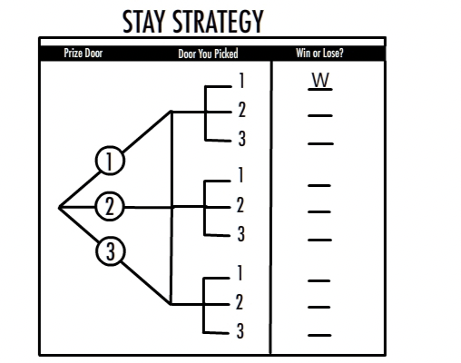

Use the tree diagram to calculate the theoretical probability of winning using the stay strategy.

1. Now let us examine the different possibilities when using the switching strategy. We will again use a tree diagram. The first branch specifies the prize door and the second branch represents the door that is initially chosen. You must fill in what door Monty Hall will reveal. Assume that if Monty has two goat doors to choose from, that he will reveal the lower numbered door (this doesn’t affect the probabilities). Then fill in the number of the door you switch to and then whether or not you win or lose. For example, when the prize is behind Door #1, and you pick Door #1, Monty will reveal Door #2 and you will switch to Door #3 and lose.

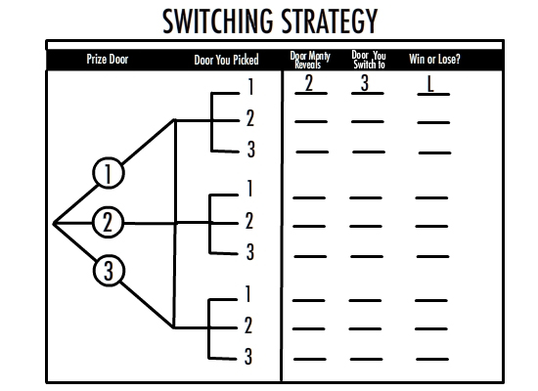

Use the tree diagram to calculate the theoretical probability of winning using the switching strategy.

1. Compare the theoretical probability and your group’s experimental probability. Also compare the theoretical probability and the class experimental probability. Which was closer to the theoretical probability, your value or the class value?

*SWITCH: The Solution – Explained*

It’s not explicitly stated that the host, Monty Hall, only shows goats. The reader is left to assume this. However, it is an important detail that provides the reason why switching doors provides a 2/3 chance of winning.

It’s clear that the “stay” strategy provides you with 1/3 chance of winning. Staying with your door is equivalent to saying, “I will choose a door and ignore everything that happens until Monty shows me what’s behind my door.” And the chance of your having picked the prize door is only one in three.

Why should you switch? There are several ways to understand why switching is better. An easy way is to ask yourself the question: “How do I lose by switching?” Switching only loses if you select the prize door first—then you end up switching away from the prize to a goat door. “How do I win by switching?” You win by choosing a goat door first. This forces Monty to show you the other goat, because he only shows goats, and guarantees you that you will switch to the prize. Since you originally had two goat doors to choose from, your probability of winning by switching is 2/3.

After a goat door is revealed, why aren’t the probabilities 50/50 for the remaining doors? Most people, seeing the problem for the first time, ask this question. In fact, when the vos Savant column was published, Parade received more than 10,000 letters including nearly 1,000 from PhDs telling them the “Switch!” strategy is wrong.

This is why the problem is so famous and why hundreds of papers and books have been published about it. The smartest mathematicians and scientists, including Nobel Prize winners, have been fooled by Monty Hall. As noted above, the reason the probabilities are not 50/50 is because Monty must only show goats. If Monty himself did not know where the prize was hidden (call him clueless Monty), and if he happened to, by luck, open a door that contained a goat, only then the probabilities would in fact be 50/50. But that’s a special case. Even if you suspected that Monty were clueless, you should switch because switching is always at least as good as staying, and it improves your chances versus staying if you’re playing with the goat-showing Monty.

It should be noted that the Monty Hall problem was presented as an **unconditional probability** (the probability that an event will occur, not contingent on any prior or related results) problem in our activity. We did this by treating the problem as a two-player game, listing all the possible outcomes of the game, and then computing the probabilities for each strategy had you decided on your strategy before the game started**.** However, the exact statement of the Monty Hall problem, above, presents a situation where you have chosen Door #1 and Monty has shown you a goat behind Door #3. As stated, it is a **conditional probability** (the probability that an event will occur given that another event has already occurred) problem and should be solved by considering only the outcomes where Door #3 has a goat. As it turns out, because Monty only shows goats in this problem, both approaches yield the same result—switching has a 2/3 chance of winning.